Jessica Rex

Dr. Gardner-McCune

Python Creative Inquiry

Game Overview: Gems

1. The goal of this game is to match rows or columns of gems in groups of 3 or more. You must get at least 70 points before the board runs out of possible moves and pass a round of hangman to get the board to reset for the next level. The final goal is to get as many points as possible.
2. Game pieces (“gems”): gem1.png gem5.png

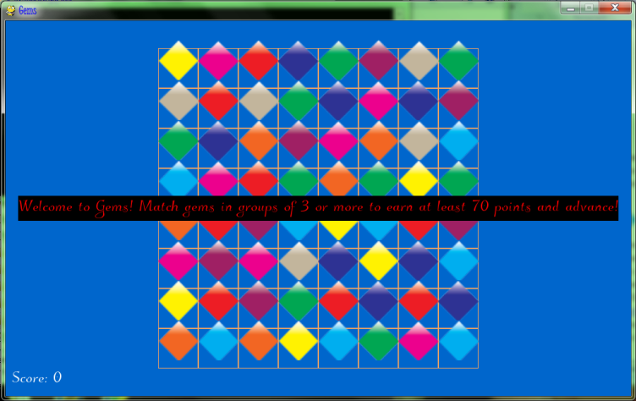 This is the intro screen for the game.

This is the game during play. 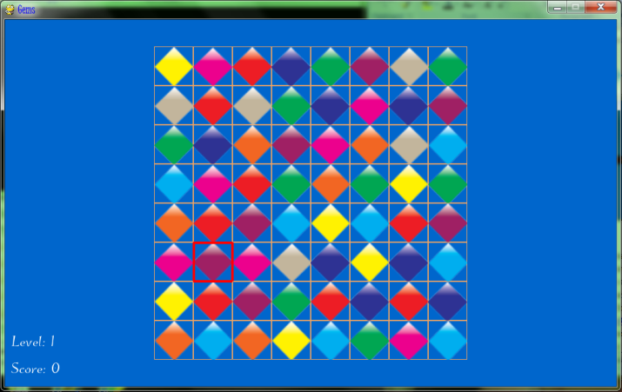

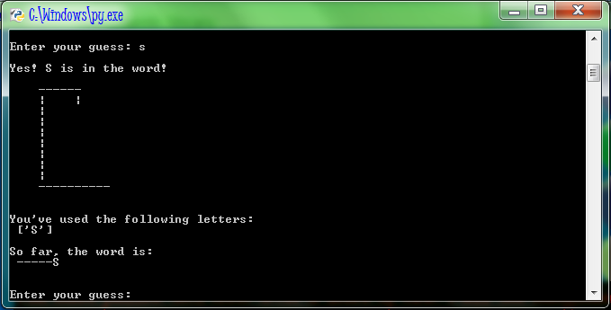 The hangman portion of the game.

1. In the tutorials, I covered the important concepts about setting up your python/pygame environment, which is something I had some issues with. I then went on to describe how to load in images, using one of my gem images as an example. Lastly, I discussed responding to mouse clicks, which is very important in my game.
2. The tutorials and my source code can be found here: <https://github.com/jrex21/PythonCI/tree/master/Gems-final%20game>
3. I assumed very little prior knowledge in my tutorials and tried my best to describe the concepts simply. Knowledge of loops and basic terminology should be all that is required to understand and apply these tutorials.